Microfluidics Lab Report

Joaquin Arcilla, November 16th 2022

# 1. Introduction

Microfluidics is the study of fluids in the small, micro scale. At this scale, a lot of the assumptions that govern macro fluidic analysis cannot be used since the changes in density, boundary layers, and friction have significant effects on the behavior of the fluid. Thus studying fluid processes at this scale helps observe when equations like Bernoulli’s equation, Equation (1), and the mass flow rate equation, Equation (3), are still applicable. These experiments help improve our understanding of blood flow, DNA, and cell behavior since these processes operate at this small scale. The main apparatus in these experiments is a microscope and a microfluidic chip, as described in the laboratory manual [1].

# (1)

# (2)

# (3)

# 2. Experimental Procedures and Results

## 

## 2.1 Procedure

For this experiment, the procedure from the laboratory manual [1] was followed. When measuring lengths from the captured images, MATLAB’s Imtool was used to measure length based on pixels. By measuring the provided scale in pixels, a scaling factor was made to convert pixel measurements to real units (i.e. μm). All lengths, whether width lengths or streak lengths, were measured in this way. Velocities were calculated by measuring streak lengths and dividing them by the shutter speed, creating a distance-traveled over time-captured value, which was the velocity of the streak.

## 2.2 Results

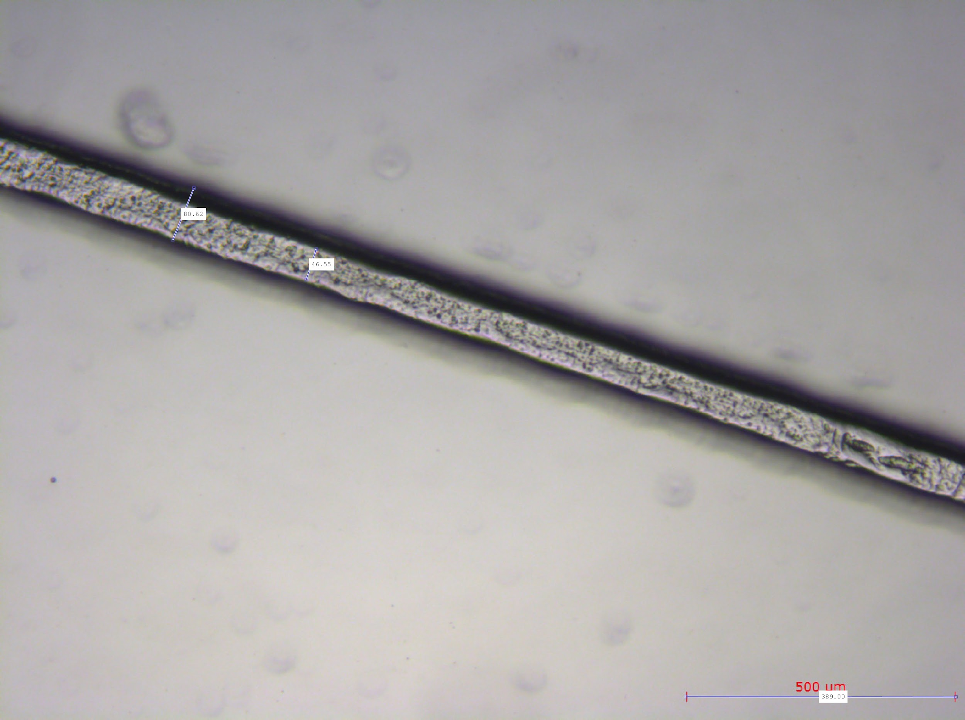

Figure [1]: Bright Field contrast image of straight channel using a 5x objective lens

### 2.2.1 Imperfections

Using a Bright field contrast method, an image of the straight channel was taken in order to view the imperfections in the microfluidic chip provided in the lab (Figure [1])

### 2.2.2 Straight Channel

By taking images of the straight channel (Figure [2]), measuring particle streaks, and dividing by shutter speed, a velocity profile was created of the fluid in the straight channel as shown in Figure [3]. A curve of best fit was applied through google sheets, which fit the expected quadratic velocity profile.

| Figure [2]: Image captured of the Straight Channel at 74.7ms shutter speed | Velocity (μm/ms) vs. Distance From Wall (μm)Figure [3]: Velocity Profile of Straight Channel |
| --- | --- |

To observe the effect of gravity on the fluid and the validity of Bernoulli’s equation, velocities were measured at different syringe elevations. The results of this experiment are found in Table [1], while the graphed data is represented in Figure [4].

| | Elevation (cm) | Average Velocity (μm/ms) | | --- | --- | | 19.5 | 1.03 +/- 0.33 | | 11.2 | 1.14 +/- 0.53 | | 5 | 0.84 +/- 40 | | 0 | 0 |   Table [1]: Average Velocity vs Elevation data | Avg Velocity (μm/ms) vs. Elevation (cm)  Figure [4]: Average Velocity vs Elevation graph, to show the relationship between gravity and the fluid. |
| --- | --- | --- | --- | --- | --- | --- | --- | --- | --- | --- | --- |

### 2.2.3 Channels With Different Widths

To analyze the effect of the change of area on the fluid, images were taken of the venturi channel and the square channel, where there is a width change. For the Square channel (Figure [5], there is a sudden increase in width, which decreases the velocity based on Equation (3) if you assume that the mass rate is the same before and after the change in width. For the Venturi channel (Figure [6]), the width change is gradual and so the velocity change is gradual as well.

| Figure [5]: Square Channel image taken at 127.7ms shutter speed. Smaller width is in the top left corner. | Figure [6]: Venturi Channel image taken at 121.7ms shutter speed. The smallest width is by the right side of the image |
| --- | --- |

Tables [2] and Table [3] show the data collected for these two channels.

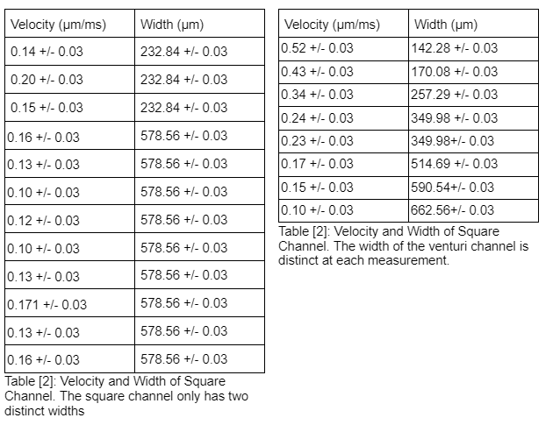

### 2.2.4 Bends

To analyze the effects of bends and curves on the fluid, images were taken of the 90° bend channel and the sinusoidal channel. Figure [7] and [8] show these images with the path of the fluid illustrated on them.

| Figure [7]: 90° bend with flow path illustrated. Taken at 23.2ms | Figure [8]: Sinusoidal bend with flow path illustrated. Taken at 18.2ms |
| --- | --- |

For the 90° bend, the average velocity before the bend was **1.04 +/ - 0.12 μm /ms** while after the bend was **0.80 +/- 0.12 μm /ms**. For the Sinusoidal bend, the average velocity before the bend was **1.9 +/-1.0 μm /ms**, while the average velocity after the bend was **1.23 +/- 0.66 μm /ms**. In both instances, the velocity of the fluid slowed down due to the bend.

# 3. Error Analysis

Quantitatively, the errors in the results were most likely due to measuring errors in MATLAB’s Imtool application. The width of the channel or the velocity streak lines may not have been measured accurately. This is reflected in the uncertainty of the measurements, which was +/- 0.05 since it's a digital measuring system. However, the process of measuring also has a major factor, like whether or not the measured line actually spans the whole width of the channel or if it is at an angle.

Error propagation was done using Equation (4) seen below. This was important for the velocity measurements since both the streak line length and the frame time had some uncertainty. This error propagation is reflected in the uncertainty of the calculated velocity values.

(4)

Qualitatively the errors stem from the usage of Bernoulli's equation and the assumptions the equation uses for its “Ideal fluid”. No fluid is perfect, which means that values derived from Bernoulli's equation don't necessarily reflect reality.

Since the fluid is not actually in steady flow, the amount of fluid passing through a point does change with time, as there isn’t enough force to keep laminar flow consistent. This means that the velocity is not constant at measured points across time. The fluid is also not incompressible, so at different sections of the chip, the density of the fluid is not constant and Equation (3) cannot be modified into Equation (5) (Seen below), which assumes constant density. Both of these factors mean that one would need to measure a lot more velocities of the fluid to have a complete understanding of the fluid’s behavior in the chips.

The last assumption assumes that no energy is lost to friction. Since all movement has friction in some form, the Total Energy of the fluid is not constant throughout the experiment. The more distance the fluid has traveled the less energy it has in the system overall. Thus the velocity of the fluid slows down as it travels across the length of the channels. The experimental results won’t fully reflect the theoretical values.

# 4. Discussion

## 4.1 Channel Imperfections

Based on Figure [1] the channel sidewall is seen to be imperfect. It isn’t perfectly smooth throughout the length. This could be caused by manufacturing errors and uncertainties, since producing these channels is difficult due to their size. The imperfections are however not too large and overall should only have a small impact due to friction. The rougher surface will generate more friction and heat loss than a smooth one would. This will decrease velocity overall, while the fluid travels in the channel.

4.2 Straight Channel

Figure [2] shows the image captured for the straight channel. Because of the no-slip assumption on fluids, theoretically, we expect that at the walls of the channel, the velocity is zero or close to zero, while at the midway point of the channel, the velocity would be at its highest. This means that the largest velocity difference would be between the middle of the channel and either edge of the channel. Figure [3] shows that experimentally this is the case. Based on the curve of best fit, the highest velocities were closer to the middle of the channel, while the smallest velocities were closer to the sides of the wall. Overall laminar flow was observed in the channel, as there was no or a little turbulence in the channel (probably due to imperfections on the wall). This can be fixed by applying more pressure to the syringe.

Based on Bernoulli’s equation, Equation (1), one could manipulate velocity in two ways, changing the pressure of a fluid, or changing the gravity potential energy by manipulating the elevation of the syringe. Table [1] and Figure [4] shows this relationship experimentally. Increasing elevation increases the velocity of the fluid, matching the expectation from Bernoulli’s equation. The relationship is radical in nature (based on the curve of best fit) which follows from Bernoulli’s equation.

4.3 Different Widths

The equation for Mass Flow Rate, Equation (3), shows that if you assume mass and density to be constant (using conservation of mass, and the incompressibility assumption) the area of a channel and the velocity of the fluid has an inverse relationship. Increasing width will decrease velocity and vice versa. Since the channel’s depth and the fluid’s density are assumed to be constant, one could rewrite Equation (3) as:

(5)

The velocity change, therefore, is based on the width ratio between the two spots velocity is measured.

Tables [2] and [3] show velocity and width measurements for the square and venturi channels. For the square channel, the average velocity width value for the smaller width was 38 +/- 5.6 μm/ms while the average of the larger width was 77.6 +/- 14 μm/ms. Since this is a real fluid, steady flow is not necessarily true, which means that this relationship won’t be strictly followed by the fluid. Likewise, because of the sudden change in width, turbulence may be introduced into the system, changing the velocities in unexpected ways.

For the venturi channel, because of the changing width, each individual velocity and width were measured and multiplied. The average value of the product was 80.7 +/- 7.7. Using Equation (4) the average uncertainty of this calculation was found to be +/- 12.2, and since the standard deviation falls within this error, the venturi behaves in an expected way based on the theory.

Looking at the data, abrupt changes seem to follow the mass flow rate relationship less than gradual ones. As stated before this could be because of turbulence, which forms at the sudden width changes. Gradual changes better follow this relationship. Gravity wouldn’t affect this relationship theoretically, since Bernoulli's equation assumes density and mass are constant, but since this is not an incompressible fluid, the velocities may differ based on how much mass is in that specific area.

4.4 Bends

Based on the data in 2.2.4, the velocity before a bend is faster than the velocity after a bend. The sharp bend however has a more pronounced difference between the two sections. This loss in velocity could be due to the fluid rebounding on itself as it hits one of the walls, colliding with more fluid and slowing down the flow. Laminar flow is seen in the middle section of the sinusoidal bend (away from the walls) but the sharp bend seems to have a collection of fluids by the edge of the bend. This could create turbulent flow around that bend. Theoretically, this is reflected in the ideas of the boundary layer, and how Bernoulli’s equation is not applicable close to surfaces.

# 5. Conclusions

In this lab, the efficacy of Bernoulli’s equation and the mass flow rate equation were assessed. On a macro level, these relationships are good representations of reality. The experimental data does follow the theory in most cases. However, once you start looking at more specific instances, especially in the microfluidic scale, the assumptions of the theories don’t remain true and a better theory should be followed or created to represent the fluid behavior. Fluids have significant density changes in microsystems, and the channels won’t have zero friction. Perhaps these equations are quite usable on the macro scale, but for microfluidics, these inaccurate assumptions should be accounted for in some way.

# 6. References and Bibliography

[1] Dr. A. Shukalyuk and M. Binette, *Introduction to Microfluidics*, University of Toronto, 2013